Remove Apple Mail Account from iPhone

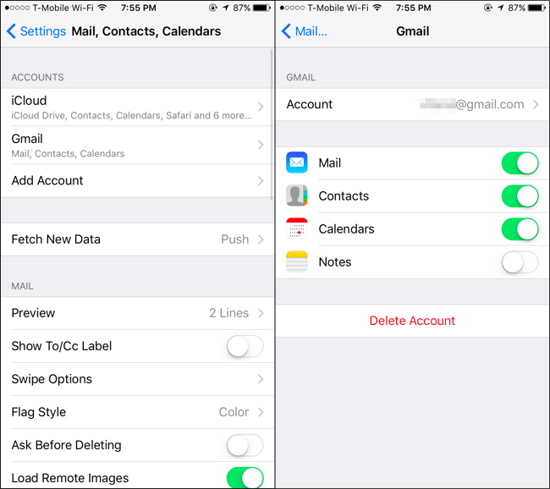
- From a Home screen, navigate: Settings > Mail. If an app isn't available on your Home screen, swipe left to access the App Library.
If unavailable, navigate: Settings > Passwords & Accounts.
- Tap Accounts.
- From the Accounts section, tap an email account.
- Tap Delete Account (at the bottom; may require scrolling).
- To confirm, tap Delete from My iPhone.

